## 

Report on

IT SUPPORT AND TICKET MANAGEMENT SYSTEM

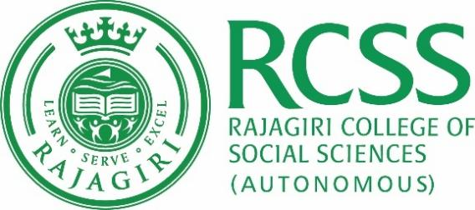

Semester VI

Master of Computer Applications

(2019-2022)

Submitted by

Caleb Antony

1924012

Under the guidance of

Dr. Bindiya M Varghese

March 2022



**DEPARTMENT OF COMPUTER SCIENCE**

**RAJAGIRI COLLEGE OF SOCIAL SCIENCES (Autonomous)**

**KALAMASSERY- 683104**

**CERTIFICATE**

This is to certify that the project titled “**It support and ticket management system**” is a bona fide work carried out by **Caleb Antony** in partial fulfillment of the requirements for the award of the Master’s degree in Computer Applications of Rajagiri College of Social Sciences (Autonomous), affiliated to Mahatma Gandhi University, during the year 2019- 2022. This project report has been approved as it satisfies the academic requirement of project work prescribed for the Master of Computer Applications.

**Dr. Bindiya M Varghese** **Dr. Bindiya M Varghese** Project Guide Dean- Computer Science

**Examiner –I (Seal) Examiner -II**

Place :

Date :

## **Declaration**

I hereby declare that this project work and the report submitted to the Department of Computer Science, Rajagiri College of Computer Science (Autonomous), Kalamassery in partial fulfillment of the award of degree of Master of Computer Applications is an outcome of my own work.

A copy of the report has been submitted to the organization for which this project was developed.

To the best of my knowledge this Project work or parts there, does not form a part of any other project work or thesis on the basis of which a degree or award was conferred on an earlier occasion.

Date :

Place : Caleb Antony

## **Acknowledgement**

I express my sincere gratitude to Dr. Binoy Joseph, Principal, Rajagiri College of Social Sciences and Dr. Bindiya M Varghese, Dean Department of Computer Science for providing all sorts of support and necessary facilities throughout the course and for the inspiration to complete my project. I would like to express my sincere gratitude for the valuable guidance and help provided by my project guide Dr. Bindiya M Varghese, whose guidance led to successful completion of my project. I am extremely thankful to Ms. Pradeep, External guide whose help and presence throughout the project. Last but not least I am also grateful to all my friends whose suggestions and help have contributed a lot to the fulfillment of this project.

## **Abstract**

The IT Support and Ticket Management System is an online web application that can be accessed through any Browser in the Desktop , laptop , or phone , It is a platform that is designed to handle all types of IT service requests from our clients. It can handle things like raising a support request for the services which are provided by the Organization titled as the ‘Sharpener Technology Services ’

In every industry there is always a waste of time and human resources because of irregular management systems. Using this website it will be easy for the clients to request for a technical support on the go and solve their problems as quickly as possible.

The administrator will be managing this application, where he will get notified about the client requests and can take necessary actions like assigning task to the employees. Using this platform the organization management can improve their efficiency as well as their productivity.

As soon as the client makes a request the admin gets notified and will be able to take necessary actions . While the client can track the progress of his project from the comfort of his home.

The goal of this web application is to reduce the workload of the employees and to serve as a platform where the information can be stored, and shared centrally, to ensure a smooth work flow. ­